Heaps
9999
80
85
17
30
84
2
16
1
1
2
3
4
5
6
8
9

7
A heap, or a maxheap, is a binary tree with two additional properties: 1) each node is larger than either of its children and 2) it is complete.

(A minheap is a heap in which each node is smaller than its children.)

Strangely enough, we do not code heaps using TreeNode. Rather, we represent the heap as an array! We do not use the zero cell. This way, any arbitrary node k has children in locations 2k and 2k+1, and a parent in k/2. Make sure these formulas work.
 | 99 | 80 | 85 | 17 | 30 | 84 | 2 | 16 | 1
[0] | [1] | [2] | [3] | [4] | [5] | [6] | [7] | [8] | [9] | [10] | [11] | [12]

Why must the heap be a complete binary tree? _______________________________________

Exercises
1. Which of the following trees is a heap?
55
33
77
221
44
887
66
b.
88
66
44
33
55
33
77
a.
88
66
77
55
44
33
22
c.
77
66
44
33
55
d.
88
88
77
66
55
33
445
e.
99
88
66
55
44
22
33
f.
77
2. Which of the following arrays have the heap property?
 | 99 | 88 | 66 | 44 | 33 | 55 | 77 | 33
0 | 1 | 2 | 3 | 4 | 5 | 6 | 7 | 8
a.
 | 99 | 88 | 77 | 66 | 55 | 44 | 33 | 22
0 | 1 | 2 | 3 | 4 | 5 | 6 | 7 | 8
b.

c.
 | 99 | 88 | 44 | 77 | 22 | 33 | 55 | 66
0 | 1 | 2 | 3 | 4 | 5 | 6 | 7 | 8

 | 99 | 88 | 66 | 77 | 22 | 33 | 44 | 55
0 | 1 | 2 | 3 | 4 | 5 | 6 | 7 | 8
d.

heapDown
e
d
uxtoShop A5
c

d

a

b

1
2
3
4
5
6
8
9

7
a

b

10

c

e
d
uxtoShop A5
c

d

a

b

1
2
3
4
5
6
8
9

7
a

b

10

c

heapUp and heapDown are the two basic heap operations. Whenever you add to or remove from a heap, the new item has to rise or fall to its proper place so that the heap is kept in heap order. Each method works in O(log n).

Let's do heapDown. For variety, we will use char data.

Let’s just put in a new value at the root, for example, put in 'b'. heapDown swaps, if necessary, that value with its largest child, and keeps swapping, until the value is in place, i.e, the heap order has been restored. Trace the movement if you put a new 'b' at the root:
[0] | [1] | [2] | [3] | [4] | [5] | [6] | [7] | [8] | [9] | [10]
null | 'b' |  |  |  |  |  |  |  |  |  | insert ‘b’
 |  |  |  |  |  |  |  |  |  |  | swap with largest child
 |  |  |  |  |  |  |  |  |  |  | swap with largest child

Go back to the original heap. Insert an 'f' at the root. What happens? There is no swapping, because 'f' is larger than its children; it has found its proper place, which is one base case. Going off the end of the array is another base case.

The heapDown algorithm is easy to say, but several things are going on: swap the current value with its largest child, then recur. If it helps, draw a flowchart. Then write pseudocode.

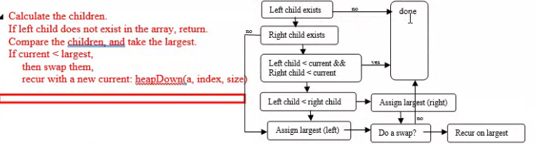

The header below is for the recursive version. (heapDown can also be done iteratively.) Assume that you have a working swap method. size in this case is just the length of the array (later, in heapSort, size will be reduced by 1 during each recursive call).

public static void heapDown(double[] array, int k, int size)

